 | Pimpri Chinchwad Education Trust’s  Pimpri Chinchwad College of Engineering (PCCoE)  Sector No. 26, Pradhikaran Nigdi, Pune – 411 044  An Autonomous Institute  Affiliated to Savitribai Phule Pune University (SPPU)
INSTRUCTIONS FOR TECHNICAL REPORT FORMATTING
Department: IT ACADEMIC YEAR: 2026-27 SEM-VII

Instructions:

It is important that the procedures listed below be carefully followed.

Following will be the order of the report.

  - Cover page and front page as per the sample attached.
  - Certificate of Completion from the institute as per the sample attached.
  - Certificate from industry on separate sheet (If sponsored Project then only).
  - Acknowledgement.
  - Contents
  - Abstract (A brief abstract of the report not more than 150 words. The heading of abstract i.e. word “Abstract” should be bold, times roman 12 pt and should be typed at the center. The contents of the abstract should be typed on a new line without space between heading and contents.
  - Chapter1 : Introduction
  - Other chapters starting on a new page.
  - References (In IEEE format)
  - Appendices if any. Appendix should contain routine calculation, standard data, derivation and relevant cyber laws.

- General instructions for Project Report
- The Project report should be complete in all respects i.e. signed by the guide, HOD
- Number of copies submitted: One only
[Copy to be submitted to Department Mrs. Neha Dike Mamafter RM Lab Oral examination with External signature]
- Maximum page limit: 10-12 only excluding cover pages & Index page
- The footer should be included as “College Name - INFORMATION TECHNOLOGY – <<Academic Year>>” and page number while the header should contain” NAME OF PROJECT”. Both header and footer should be TIMES NEW ROMAN 10pt and centrally aligned
- Start numbering the pages from the Table of contents page as page 1
- Pages before table of content should not be numbered
- Page Size: A4
- Printing on single side of the pagesonly
- Paper thickness: minimum 85 GSM (grams per square meter)
- Typesetting: Latex Compulsory , Entire Report must be in point Times New Roman Font, 1” margin from all sides, 1.5 spacing on all lines

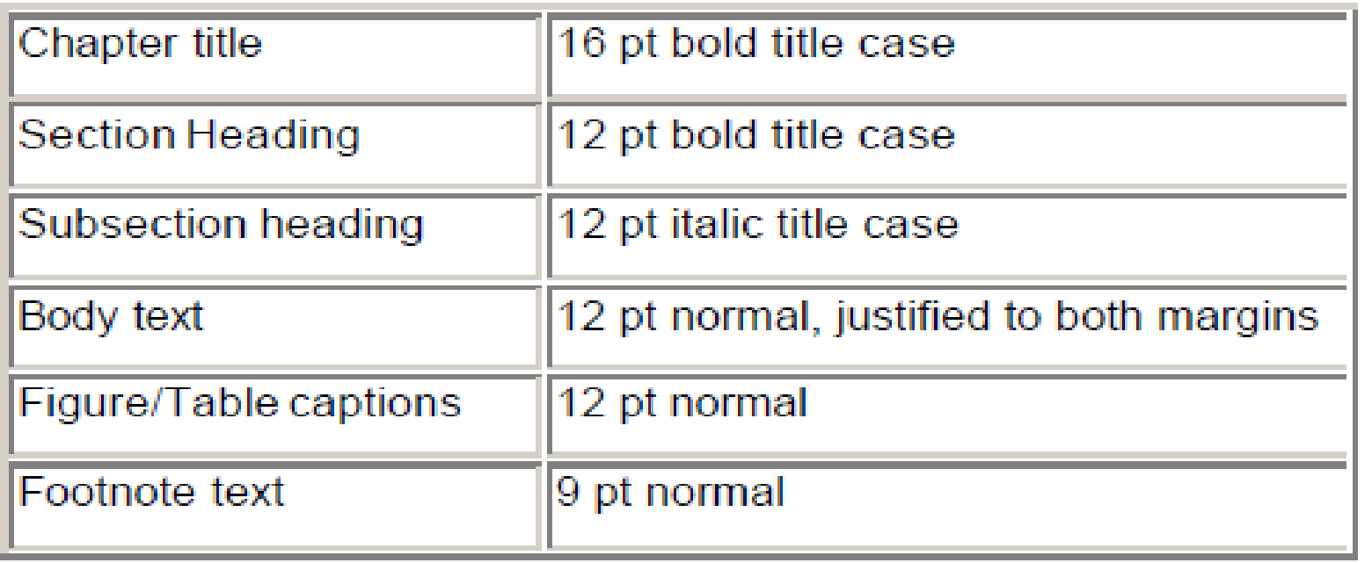

- The main part of the manuscript should be TIMES ROMAN 12 pt and justified. Use 1.5 line spacing and justify aligned
- No Abbreviations in the title of the Project
- Each Chapter must start on new page, center aligned
- Chapter titles should be bold with 16pt typed in all capital letters and should be aligned at the center of the page. Section heading should be aligned at the left with 12pt and bold and capitalized. Section subheading should be aligned at the left with the title case (the first letter of each word is to be capitalized). Leave two spaces between section headings and 1 space between two section subheadings.
- All chapters, section heading and subheadings should be numbered. For chapters use numbers 1, 2……. And for subheadings 1.1, 1.2 etc. and section subheadings 2.1.1, 2.2.2, 2.3.1 etc.
- Illustrations (Charts, drawings photographs, figures) are to be in the text. Use only illustrations really pertinent to the text. Illustrations must be sharp, clear, black and white. Illustrations downloaded from internet are not acceptable.
- Illustrations (diagram or picture) should not be more than two per page. One could be ideal
- Figure No. and title at bottom with 12pt.
- Legends below the title in 10pt.
- Proper margin in all sides.
- Illustrations as far as possible should not be Xeroxed (photo copy)
- Numbering and Title to all the figures is mandatory, title of the figure to be given below the figure
- Numbering and Title to all the Tables is mandatory, title of the Table to be given above the Table
- In the body of the report, References should be cited in square brackets for example [MNRE Annual Report,2014]
- References should be either in order as they appear in the paper or in alphabetical order by last name of first author
- At the end of the report references should be mentioned as follows
Journal paper reference should be mentioned as follows
      - S.K. Kenue and J.F. Greenleaf, “Limited angle multifrequency diffraction tomography,” IEEE Trans. Sonics Ultrason., vol. SU-29, no. 6, pp. 213-2 17, July 1982.

Book references should be mentioned as follows
      - Duffie, J.A., Beckman, W.A., Solar Engineering of Thermal Processes, John Wiley and Sons, New York,1991.
      - P.M. Morse and H. Feshback, Methods of Theoretical Physics. New York: McGraw Hill, 1953.

CONTENTS (14/bold/upper case)

CERTIFICATE FROM INDUSTRY IF APPLICABLE | I | (12/bold/upper case)
ACKNOWLEDGEMENT | II | (12/bold/upper case)
CERTIFICATE OF COMPLETION FROM INSTITUTE | III | (12/bold/upper case)

CHAPTER  (12/bold/upper case) |  | TITLE(12/bold/upper case) | PAGE NO.
 | INTRODUCTION
 |  | - Background of the Project | 2 Pages Only
 |  | Motivation
 |  | Aim and objectives
 |  | Sustainable Development Goals (SDG) addressed
 | LITERATURE REVIEW |  | 3-4 Pages Only
 |  | - Review of Existing Research / Technologies
 | 2.2 | - Comparative Analysis & Research Gap
 | PROPOSED METHODOLOGY |  | 2-3 Pages Only
 | PERFORMANCE METRICS |  | 1 Pages Only
 | CONCLUSION AND FUTURE SCOPE |  | 1 Pages Only
 | REFERENCES (IEEE Reference Style) |  | 1 Pages Only
APPENDIX
Proof of Research Paper submission

** Note report should not exceed more than 15 pages including 5 diagrams and test cases

Add Research Methodology Laboratory and Page Numbers in Footer Note.

